**Smart Dustbin**

**By:**

**Manoj Kutala**

**Kariketi Tharun Reddy**

**Smart Dustbin**

**ABSTRACT:**

In the recent decades, Urbanization has increased tremendously. At the same phase there is an increase in waste production. Waste management has been a crucial issue to be considered. This paper is a way to achieve this good cause. In this paper, smart bin is built on a platform Arduino Uno board which is interfaced with GSM modem and Infrared sensor. Infrared sensor is placed at the top of the dustbin which will measure the stature of the dustbin. The threshold stature is set as 10cm. Arduino will be programmed in such a way that when the dustbin is being filled, the remaining height from the threshold height will be displayed. Once the garbage reaches the threshold level IR sensor will trigger the GSM modem which will continuously alert the required authority until the garbage in the dustbin is squashed. Once the dustbin is squashed, people can reuse the dustbin. At regular intervals dustbin will be squashed. Once these smart bins are implemented on a large scale, by replacing our traditional bins present today, waste can be managed efficiently as it avoids unnecessary lumping of wastes on roadside. Foul smell from these rotten wastes that remain untreated for a long time, due to negligence of authorities and carelessness of public may lead to long term problems. Breeding of insects and mosquitoes can create nuisance around promoting unclean environment. This may even cause dreadful diseases.

**PROBLEM STATEMENT:**

To implement a smart bin built on a microcontroller based platform Arduino Uno board which is interfaced with GSM modem and Ultrasonic sensor which can gives the status of the waste present in the dustbin to the municipal authority.

**REQUIRMENT SPECIFICATION:**

ESP32 with GSM  
 Gyroscope

IR sensor

Humidity sensor

GSM

**ARCHITECTURE DIAGRAM / WORK FLOW :**

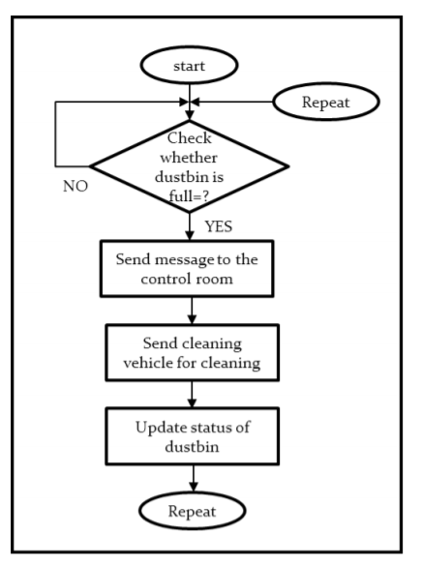

**ESP32 with GSM:**

The ESP32 WIFI Module is a self-contained SOC with integrated TCP/IP protocol stack that can offer any microcontroller access to your Wi-Fi network. It is capable of either hosting an application or offloading all WiFi networking functions from another application processor.

**IR sensor:**

An Infrared sensor is a device that measures the distance of an object with the help of infrared waves. It measures distance through sending out an IR wave and receiving for that wave to bounce back.

Distance = 1/2 × T × C

**Gyroscope :**

A **gyroscope** is a device that uses Earth's gravity to help determine orientation. Its design consists of a freely-rotating disk called a rotor, mounted onto a spinning axis in the centre of a larger and more stable wheel.

**Humidity sensor:**

A **humidity sensor** (or hygrometer) senses, measures and reports both **moisture** and air temperature. The ratio of **moisture** in the air to the highest amount of **moisture** at a particular air temperature is called relative **humidity**.

**GSM:**

**GSM (Global System for Mobile Communications, originally Groupe Special Mobile)**, is a standard developed by the European Telecommunications Standards Institute (ETSI). This was created to describe the protocols for second-generation (2G) digital cellular networks used by mobile phones and is now the default global standard for mobile communications – with over 90% market share, operating in over 219 countries and territories.

**Implementation:**

All the data from the sensors (IR, gyroscope, humidity) gives the information of Distance, orientation, temperature, humidity. These data are pushed to the cloud server with the help of esp32 Wi-Fi module where the Wi-Fi router is enabled by internet connection. GSM gives the real time latitude and longitude of the dustbin, connect the GSM data with the google map API then locate the dustbins in the map.

This project is concerned about two sides of the dustbin

1. Dustbin user
2. Dustbin managers

User:

Search for nearby dustbins

By computing the data in the cloud provide the real time location of nearby dustbins to the user with the following restrictions

1. Filled dustbins- by manipulating the data of IR sensor, if the distance is less than 7cm then these dustbins are considered as filled up dustbins. Hence they are not displayed(hidden).
2. Fallen dustbins - by manipulating the data of gyroscope sensor, detect the orientation of the dustbins if there is change in axis by 90 degree then it is considered as fallen one. Hence they are not displayed(hidden).
3. Alert users about the type of waste in the dustbin – humidity sensor reading gives the moisture content of the air. If the moisture content is more, users are shown a caution message because the dustbin may smell bad.
4. Location of dustbin is shown to users by computing the data of GSM. GSM sends the latitude and longitude of the dustbin to the cloud. The location of dustbin is displayed to users from the cloud.

Managers:

1) Filled dustbins are displayed to workers. Hence workers can collect the wastes from the dustbin. Data from IR sensor is computed to find out whether the dustbin is full or not.

2) Fallen dustbins – using the data from gyroscope sensor, we detect the orientation of dustbin and fallen dustbins are displayed to the workers so that they can reorient the dustbins.

3) Dustbins with high moisture content are displayed separately to workers and those dustbins are to be emptied immediately to prevent bad smell.

4) Same as user side, location is displayed to workers by analysing the latitude and longitude data sent by GSM .

**Conclusion :**

Technology can be used in any walks of our life but the main part is in implementing the technology. Even the small measures taken in taking care of our environment may end up with the good results. Engineers are those who can implement technology in human life in a sustainable way and we hope on future engineers will play the best part in it.